Survey Module

- Create new Survey
Login to BIOME, navigate your mouse cursor to “Sightings”, click on “Surveys”
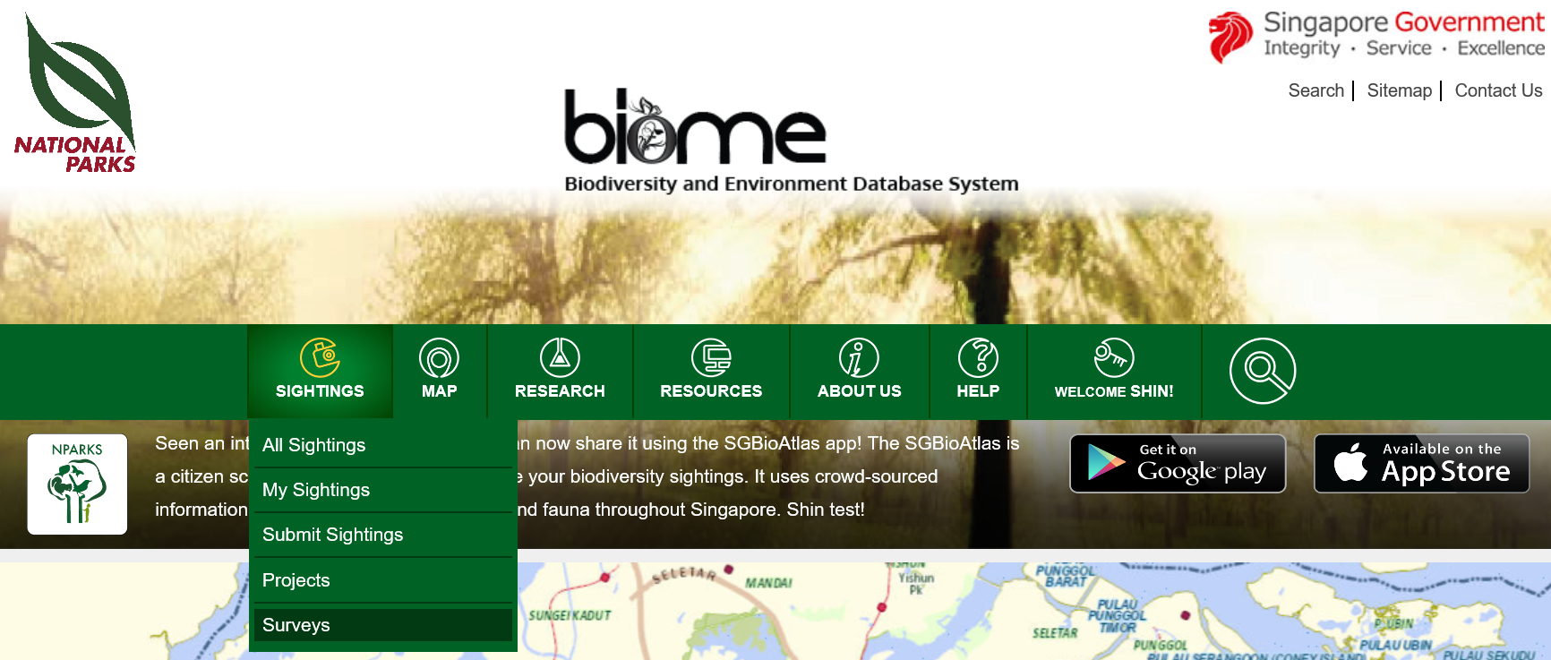
Select “Surveys”
Click on “Request Survey”
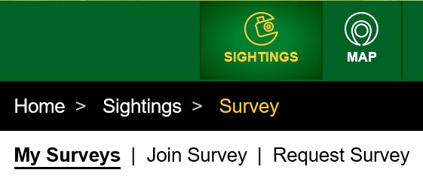
Select “Request Survey”
Fill up the form
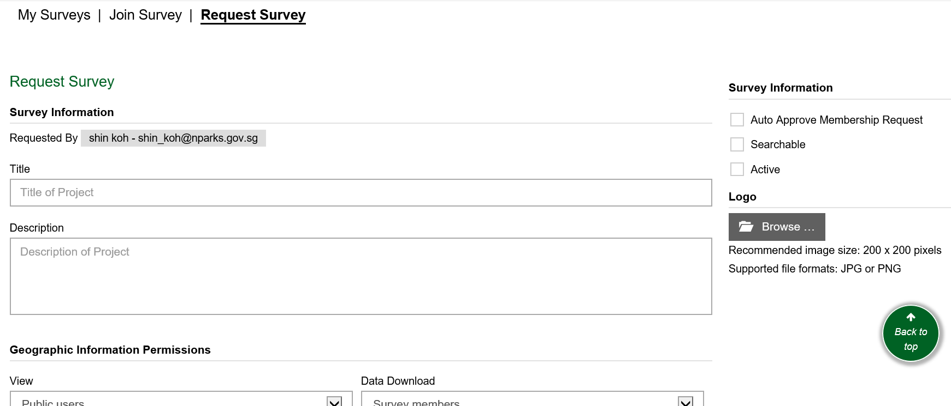
Some notes:
Form fields | Descriptions
Auto Approve Membership Request | When checked, anyone who join your Survey will auto be approved. Otherwise, Survey Admins will have to approve each request.
Searchable | When checked, your Survey will be listed for other users to join. Otherwise, your Survey will be hidden and not be listed for other users to join. You may then use “Invite User” function to invite specific users (via email address or BIOME user name). See section “Invite User”.
Active | When checked, your Survey is open for users to join. User may also participate in your Survey data collection.
Geographic Information Permissions – View | Feature is not available yet

- Join Survey
Click on “Join Survey”
Select “Join Survey”
Click on “Join Survey” to join a survey.

- Submit Survey Data
Click on “My Survey”
Select “My Survey”
Click on “Submit” to submit data for survey.
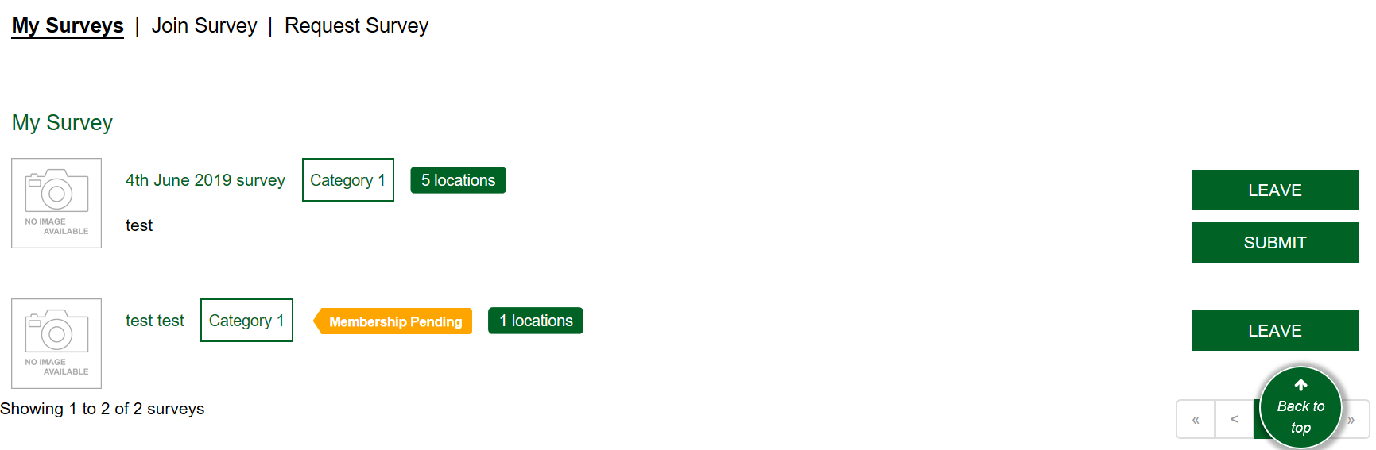
Select “Submit”

- Submit Survey Data (SGBioAtlas)
Login to SGBioAtlas, select “My Survey”, select the survey you wish to participate in and select “Start Survey”.
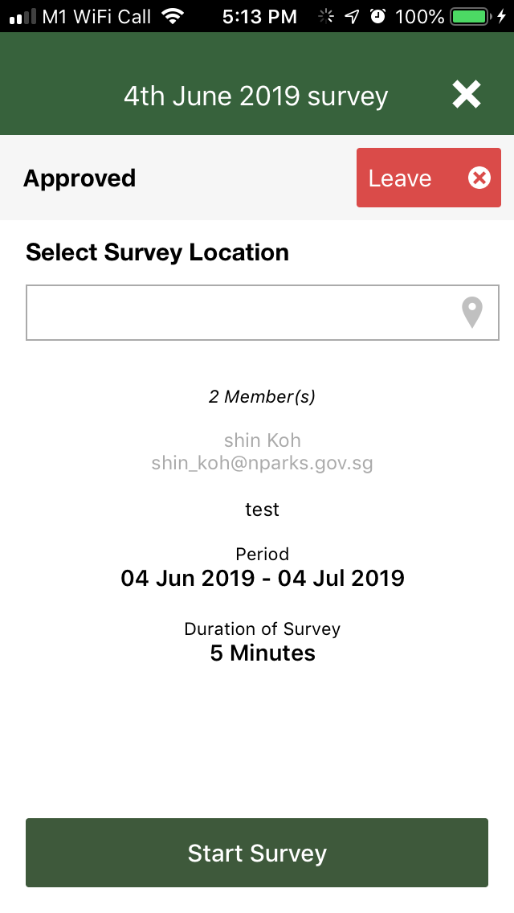
Select “My Survey”

- View and Download Survey Submissions
Click on “My Survey”
Select “My Survey”
Click on “Survey Title” to view survey submission.
Select “Survey Title”
Click on “View” to view submission details. Click on “Download CSV” to download all submissions to csv file (which you may open using MS Excel).
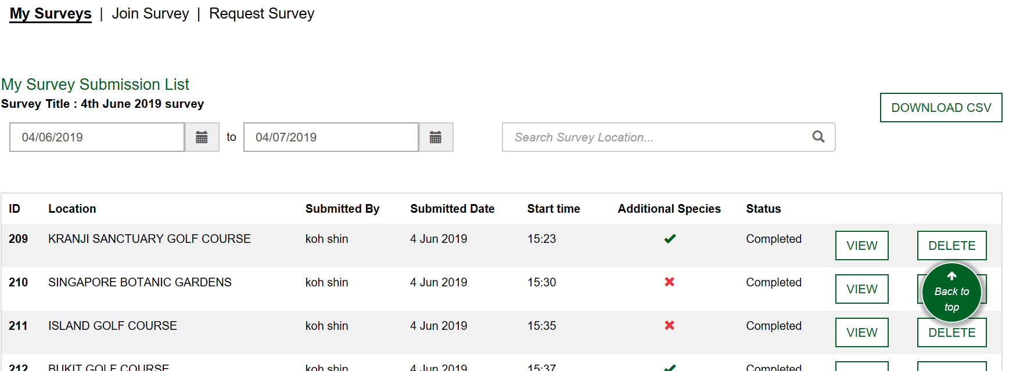
Select “View”
Select “Download CSV”

- View Survey Submissions (SGBioAtlas)
In SGBioAtlas, select “My Account”, select “My Survey Submissions”.

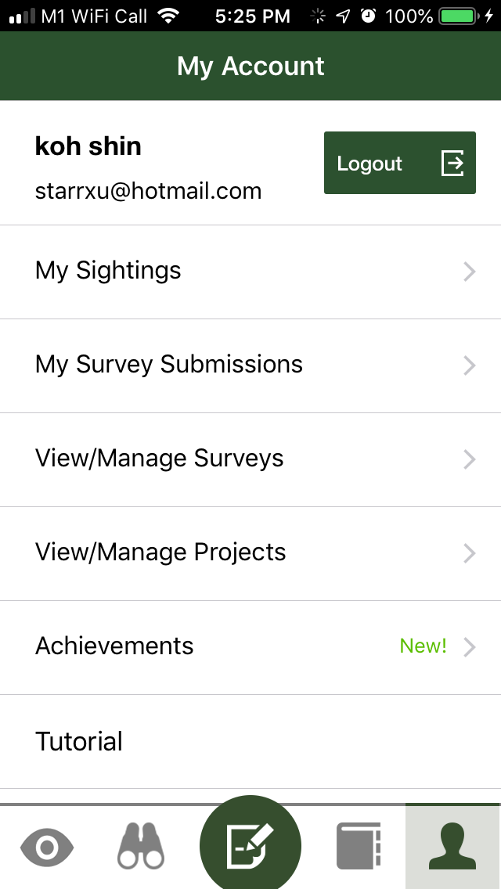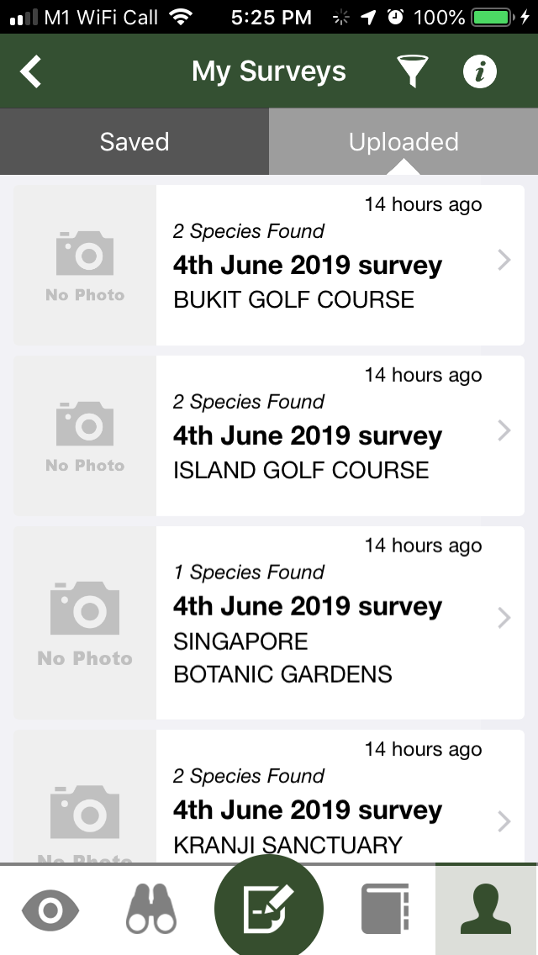
Select “My Survey Submissions”
Select “My Account”

- Additional feature: Invite User
Search by user name or email address. Click “Invite” to send email to invite user to join your Survey. For tracking purpose, joined members are listed in this page. You may resend email by clicking on “Send Email” if a user has not joined your previous email invitation.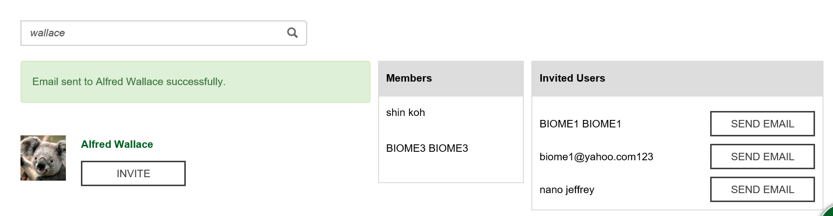
Search users by name or email address

